Use Case Documentation
End-to-End Data Engineering & Analytics Pipeline

Project: Use case Scenario for ABC retail solutions
Domain: Data Engineer Role
Tech Stack: Python, Pandas, Scikit-Learn, Excel and Power BI
Name: Anna Binoy
College: CMR Institute of Technology

1. Executive Summary
ABC Retail Solutions operates across five major Indian cities, processing thousands of retail transactions daily from multiple source systems. This project delivers a production-grade, end-to-end data engineering and analytics pipeline that transforms raw, messy transaction data into actionable business intelligence — complete with KPI dashboards, sales forecasting, and interactive Power BI visualizations.

1.1 Project Objective
The primary objective is to architect and implement a modular Python pipeline that ingests dual-source retail transaction datasets, resolves data quality issues, protects customer privacy, enriches transactions with product master data, generates business KPIs, forecasts future revenue, and delivers a formatted Excel output consumed by a Power BI dashboard.

1.2 Key Outcomes at a Glance
Outcome | Metric | Business Value
Transactions Processed | ~7,900+ | Full audit trail preserved
Total Revenue Computed | ₹1.16B+ | Accurate P&L foundation
Cities Analysed | 5 | Regional strategy enablement
Product Categories | 4 | Category-level margin analysis
Unique Products | 10 | SKU-level performance ranking
Forecast Horizon | 6 Months | Proactive inventory planning
Data Quality Issues Fixed | 8 types | Reliable, consistent analytics
PII Fields Protected | 3 (email, phone, name) | Compliance & privacy by design
Dashboard Pages | 5 (Power BI) | Executive to operational insights

1.3 Technology Summary
The pipeline is built entirely in Python, leveraging Pandas for data manipulation, NumPy for numerical operations, Scikit-Learn for forecasting (Linear Regression), OpenPyXL for Excel generation, and Python's built-in logging module for pipeline observability. The final output is consumed by Power BI Desktop for interactive visualization.

2. Business Problem
ABC Retail Solutions receives transaction data from two independent source systems (retail_data1 and retail_data2), representing different points-of-sale channels — online and offline. While both datasets share the same schema, the data arriving from each source carries significant quality issues that, left unresolved, directly undermine the accuracy and reliability of business reporting.

2.1 Data Quality Challenges
Data Issue | Root Cause | Business Impact if Unresolved
Duplicate Transactions | Double-sends from source systems | Revenue double-counting; inflated KPIs
Missing Values | Incomplete form submissions | Gaps in aggregations; skewed averages
Inconsistent Categories | No enforced data dictionary | Split metrics; inaccurate category revenue
Inconsistent Product Names | Manual entry variation | Fragmented product analytics
Mixed Date Formats | Multiple ingestion systems | Failed time-series analysis; broken forecasts
Invalid Quantities | Data entry errors | Negative or zero-revenue calculations
Missing Prices | Lookup table gaps | Revenue undercount; incorrect order values
Exposed PII | No masking at source | Privacy risk; regulatory non-compliance

2.2 Why These Issues Block Reliable Analytics
Each data quality issue compounds the others. A single duplicate transaction with an inconsistent category and a missing price will create revenue that is counted twice in the wrong segment with an incorrect value. The downstream KPI dashboard, the sales forecast, and the executive decisions built on them all inherit this error. The only robust solution is a systematic, phase-by-phase data engineering pipeline that resolves each issue at its source before allowing data to flow downstream.

3. Dataset Description

3.1 Data Sources
All source data is delivered in a single Excel workbook (source_data.xlsx) containing three sheets. This mirrors a common real-world scenario where a vendor or internal system delivers a bundled data file at regular intervals.

Sheet | Rows (approx.) | Description
retail_data1 | ~4,000 | Online channel transactions — includes full customer info, product details, payment data, and timestamps
retail_data2 | ~4,000 | Offline / in-store transactions — same schema as retail_data1 but with higher incidence of data quality issues
product_details | 10 | Master product dimension table — canonical product names, categories, and standard prices (source of truth)

3.2 Column Reference — Transaction Datasets
Column | Type | Description
transaction_id | String | Unique identifier for each transaction
customer_id | String | Unique customer identifier
customer_name | String (PII) | Customer full name — masked in pipeline
product_id | String | Product identifier — foreign key to product_details
product_name | String | Product name — standardised against dimension table
category | String | Product category (Electronics, Clothing, Furniture, Home Appliances)
city | String | Transaction city (Bangalore, Chennai, Delhi, Hyderabad, Mumbai)
transaction_date | Date | Date of transaction — mixed formats in source; standardised to YYYY-MM-DD
quantity | Integer | Units purchased — must be > 0
price | Float | Unit price — imputed from product_details if missing
discount | Float | Discount fraction [0.0–1.0] — clipped to valid range
payment_method | String | Payment type (Credit Card, UPI, Cash, etc.)
payment_status | String | Transaction outcome (Successful / Failed / Pending)
email | String (PII) | Customer email — masked in pipeline
phone | String (PII) | Customer phone — masked in pipeline

3.3 Dataset Statistics
Statistic | Value
Total source records (both sheets combined) | ~8,000
Records after cleaning (duplicates & invalids removed) | ~7,900+
Date range | Multi-month; spans 12+ months
Cities | 5 (Bangalore, Chennai, Delhi, Hyderabad, Mumbai)
Product categories | 4 (Electronics, Clothing, Furniture, Home Appliances)
Unique products | 10 (Laptop, Phone, Shirt, Shoes, TV, Sofa, Dining Table, Mixer Grinder, Refrigerator, Microwave)
Payment methods | Multiple (Credit Card, Debit Card, UPI, Cash, Net Banking)
PII fields | 3 (email, phone, customer_name)

4. Architecture

4.1 High-Level Architecture
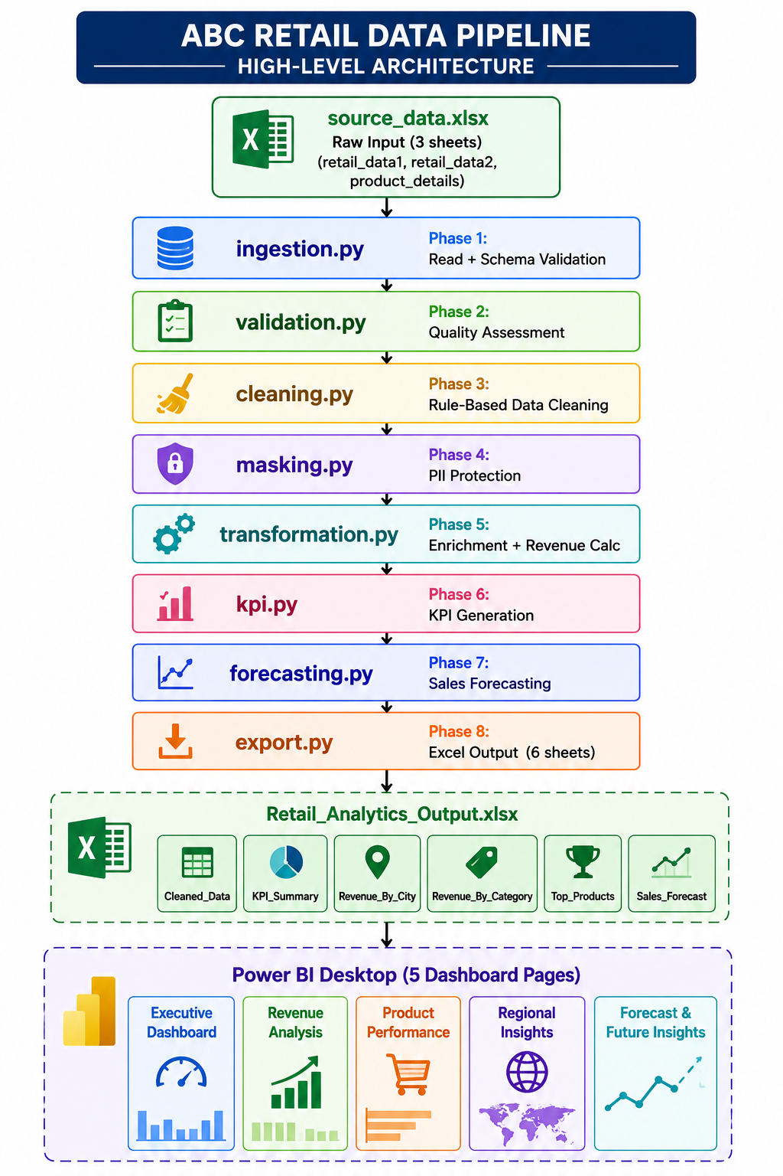
The pipeline follows a linear, modular architecture. Each stage has a single responsibility, produces a well-defined output, and passes that output to the next stage. This design makes the pipeline easy to test, extend, and debug.

4.2 Data Flow Architecture
Data flows unidirectionally through the pipeline. Each module receives a Pandas DataFrame (or dict of DataFrames), applies its transformations, and returns a new DataFrame. No module modifies data from a previous stage in-place after that stage has completed, ensuring reproducibility and testability.

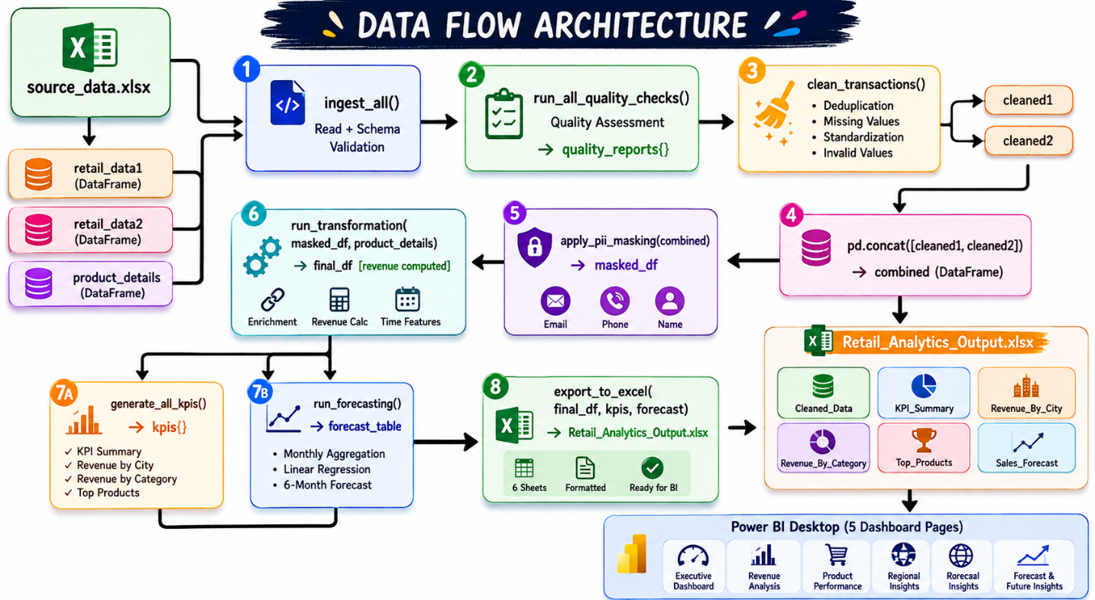
.

4.3 Module Interaction Diagram
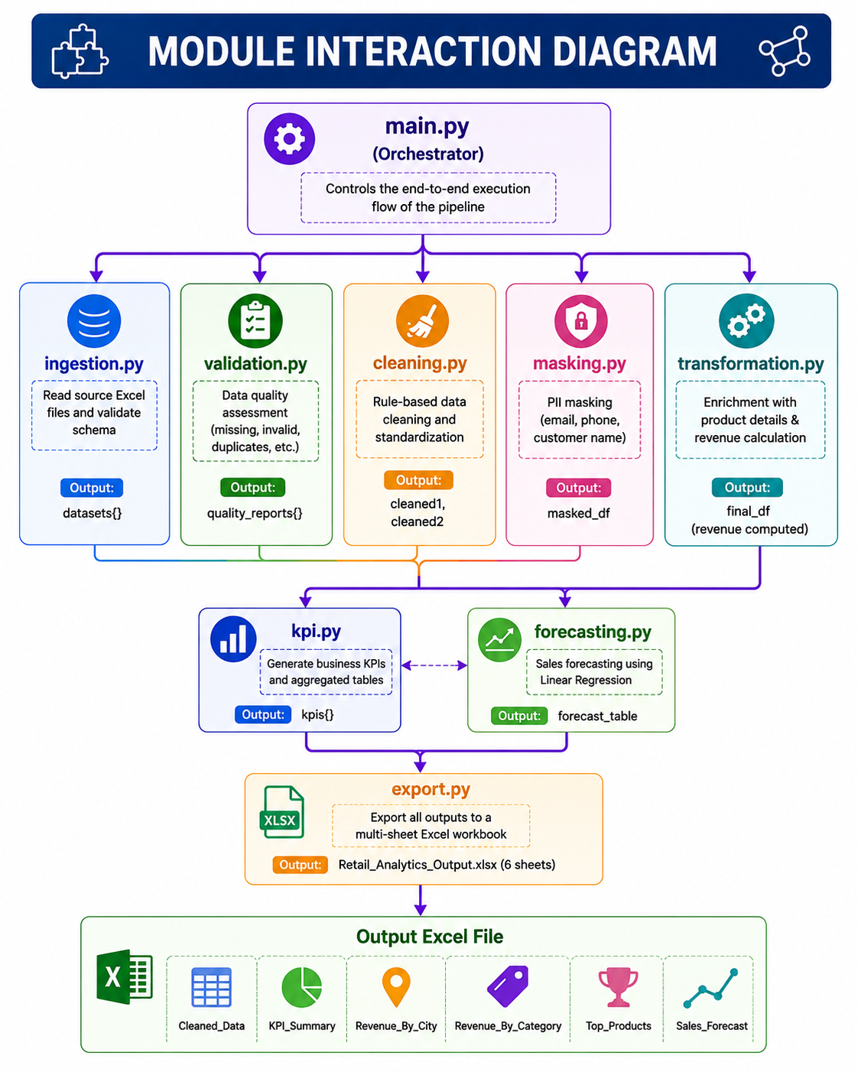
The orchestrator main.py calls each module in sequence. Modules are loosely coupled — each accepts standard Pandas DataFrames and returns DataFrames, making them independently testable and replaceable
Module | Phase | Responsibility
ingestion.py | 1 | Read Excel sheets, validate schema against expected column list, log row and null statistics
validation.py | 2 | Generate missing value, duplicate, invalid value, and schema validation reports for quality monitoring
cleaning.py | 3 | Apply 8 rule-based cleaning steps: deduplication, category standardisation, date parsing, quantity/price/discount validation
masking.py | 4 | Apply deterministic PII masking to email, phone, and customer_name fields before any downstream processing
transformation.py | 5 | Left-join with product master data, override transaction-level product/category/price with authoritative values, compute revenue
kpi.py | 6 | Generate four KPI DataFrames: executive summary, revenue by city, revenue by category, top 10 products
forecasting.py | 7 | Aggregate to monthly revenue, encode month index feature, train LinearRegression, evaluate with MAE/RMSE/R², forecast 6 future months
export.py | 8 | Write 6 formatted, styled sheets to Retail_Analytics_Output.xlsx using OpenPyXL with alternating row fills, frozen panes, and auto-width
main.py | Orchestrator | Sequential pipeline runner — imports and calls all modules, passes DataFrames between stages, logs progress at each phase boundary

4.4 Power BI Architecture
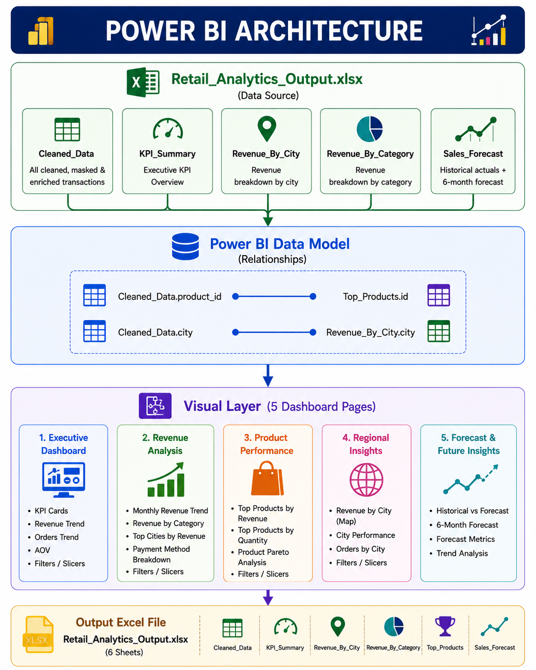

5. End-to-End Pipeline
Each phase of the pipeline is designed with a clear objective, defined inputs and outputs, and explicit reasoning for its inclusion. Together they form a complete data engineering workflow from raw source files to business-ready dashboards.

Phase 1 — Data Ingestion (ingestion.py)
Objective | Read all three sheets from source_data.xlsx, validate schema, and log summary statistics
Input | source_data.xlsx (retail_data1, retail_data2, product_details sheets)
Processing | pd.read_excel() per sheet; column set comparison against REQUIRED_COLUMNS dict; null count and duplicate count logging
Output | Dict of three validated Pandas DataFrames
Why Necessary | Schema validation at ingestion prevents downstream failures caused by missing columns. Early logging surfaces data volume changes between deliveries.

Phase 2 — Data Quality Assessment (validation.py)
Objective | Generate detailed quality reports to quantify data issues before cleaning begins
Input | Raw DataFrames from Phase 1
Processing | Null count/percentage per column; full duplicate detection; invalid value checks (quantity ≤ 0, price ≤ 0, discount outside [0,1])
Output | quality_reports dict containing missing, duplicates, and invalid DataFrames
Why Necessary | Provides an auditable record of data quality state before the pipeline applies fixes — critical for compliance and debugging.

Phase 3 — Data Cleaning (cleaning.py)
Objective | Apply eight sequential, rule-based cleaning transformations to produce a consistent, valid transaction dataset
Input | Raw transaction DataFrames + product_details reference
Processing | Dedup, status-priority dedup, category standardisation, product name standardisation, date parsing, quantity validation, price imputation, discount clipping
Output | cleaned1, cleaned2 DataFrames; then pd.concat() → combined
Why Necessary | Data cleaning is the foundation of all downstream analytics. Without it, KPIs are unreliable and forecasts are misleading.

Phase 4 — PII Protection (masking.py)
Objective | Irreversibly mask all customer PII before the data is enriched, aggregated, or exported
Input | combined (cleaned DataFrame)
Processing | Email masking (first 2 chars visible); phone masking (last 4 digits visible); name masking (first char per word visible)
Output | masked_df — identical schema but with PII fields replaced by masked values
Why Necessary | Minimal exposure principle — mask as early as possible. Once masked, PII cannot leak through any downstream export, aggregation, or dashboard.

Phase 5 — Data Transformation (transformation.py)
Objective | Enrich transactions with authoritative product master data and compute revenue for every row
Input | masked_df + product_details DataFrame
Processing | LEFT JOIN on product_id; override product_name/category/price with dimension values; Revenue = Quantity × Price × (1 – Discount); add year/month/month_year features
Output | final_df — enriched, revenue-calculated, time-featured DataFrame (~7,900+ rows, 20+ columns)
Why Necessary | Revenue is the central KPI. It can only be correctly calculated after cleaning validates quantities and prices, and after product master data overrides any inconsistent transaction values.

Phase 6 — KPI Generation (kpi.py)
Objective | Compute all business KPIs via Pandas aggregations — no hardcoded values
Input | final_df
Processing | Four independent aggregation functions: kpi_summary(), revenue_by_city(), revenue_by_category(), top_products()
Output | kpis dict with four DataFrames, each ready for Excel output and Power BI import
Why Necessary | Separating KPI logic into a dedicated module ensures business rules are centrally maintained and reusable across multiple output formats.

Phase 7 — Sales Forecasting (forecasting.py)
Objective | Produce a 6-month forward revenue forecast using a trained Linear Regression model
Input | final_df
Processing | Monthly aggregation → month_index feature engineering → LinearRegression training → in-sample prediction → evaluation (MAE, RMSE, R²) → 6 future period projection
Output | forecast_table (month | actual_revenue | forecast_revenue) + metrics dict
Why Necessary | Forward-looking forecasts enable proactive inventory management, budget planning, and target-setting — converting historical data into strategic value.

Phase 8 — Excel Export (export.py)
Objective | Write all pipeline outputs to a professionally formatted 6-sheet Excel workbook
Input | display_df, kpis dict, forecast_table
Processing | OpenPyXL workbook creation; per-sheet style functions (header fill, alternating row fills, auto-column widths, freeze panes, title rows)
Output | Retail_Analytics_Output.xlsx — 6 sheets, production-formatted
Why Necessary | Excel is the universal format for non-technical stakeholders. Formatted output with frozen panes and styled headers makes the data immediately usable without further processing.

Phase 9 — Power BI Visualization
Objective | Deliver interactive, stakeholder-ready business intelligence dashboards
Input | Retail_Analytics_Output.xlsx connected as Power BI data source
Processing | Data model with relationships; DAX measures for Total Revenue, AOV, MoM Growth; 5 report pages with slicers, filters, and drill-down capability
Output | 5-page interactive dashboard covering executive KPIs, revenue analysis, product performance, regional insights, and forecast visualization
Why Necessary | Raw data and Excel tables are insufficient for executive decision-making. Interactive dashboards with visual filtering transform the pipeline output into actionable intelligence.

6. Data Quality Strategy
Every cleaning decision in this pipeline is rule-based, deterministic, and documented. The guiding principle is: apply the most conservative, business-safe fix possible — never invent data, only recover it from authoritative sources or remove it when recovery is impossible.

6.1 Duplicate Removal
Two categories of duplicates are handled independently. Full duplicates — rows identical across all columns — are caused by pipeline double-sends and carry no additional information. They are dropped, keeping the first occurrence. Partial duplicates — same transaction_id, customer_id, and product_id but with different payment_status — represent a more nuanced case where a transaction was submitted twice, once successfully and once with a failure. The strategy is to sort by status priority (successful → failed → pending) and keep only the highest-priority record. Business impact of leaving duplicates: Total Revenue would be overstated, order counts inflated, and customer frequency metrics distorted - making every downstream KPI unreliable.

6.2 Invalid Quantity Removal
Rows where quantity is null, zero, or negative are dropped entirely. A transaction with zero or negative quantity has no valid business interpretation - it cannot represent a purchase, a return, or a correction in this dataset. Imputing a quantity (e.g., replacing with 1) would be an assumption that overrides unknown business reality. The conservative approach is deletion. Business impact: Retaining these rows would produce transactions with zero or negative revenue, distorting average order values and potentially inverting the revenue trend.

6.3 Price Imputation
Missing or zero prices are filled using a two-tier strategy. First, the pipeline looks up the product_id in the product_details dimension table, which is the authoritative master data source for pricing. If the product_id is not found in the dimension (a rare data quality gap), the column median is used as a safe fallback. Deletion is avoided because losing a transaction due to a missing price — when the correct price is available in the master data - would be an unnecessary data quality loss. Business impact: Missing prices left unfilled would produce zero-revenue transactions, significantly underreporting total revenue.

6.4 Discount Validation
Discounts outside the valid range [0.0, 1.0] are clipped rather than dropped. A negative discount or a discount greater than 1 is a data entry error, but the transaction itself is valid. Clipping to 0.0 for negatives (no discount assumed) and 1.0 for values above 1 (100% discount assumed) preserves the transaction with a conservative, safe value. Business impact: An unclipped discount of 1.5 would produce negative revenue for that row. An unclipped discount of -0.2 would produce revenue higher than the full price — both distorting margin analysis.

6.5 Date Standardisation
The source data contains dates in two formats: Python datetime objects (from Excel date cells) and string representations in MM-DD-YYYY format. The pipeline uses pd.to_datetime (errors='coerce'), which parses both formats and converts unparseable values to NaT. Rows with NaT dates are dropped - a transaction date is a non-negotiable anchor for time-series analysis, and there is no safe way to impute it. All valid dates are then formatted to a standard YYYY-MM-DD string. Business impact: Mixed date formats would cause groupby(month) aggregations to fail or produce nonsensical time-series data, breaking the monthly revenue aggregation used in forecasting.

6.6 Product and Category Standardisation
Inconsistent product names (e.g., 'laptop', 'LAPTOP', 'Laptop Pro') and category values (e.g., 'elec', 'ELEC', 'Electronics') are normalised using two mechanisms. First, a static lookup dictionary applies known aliases using lowercase-strip matching. Second, the product_details dimension join in the transformation phase overrides all transaction-level product names and categories with the authoritative dimension values. Business impact: Without standardisation, a 'Laptop' and a 'laptop' would appear as separate products in Power BI, artificially splitting product revenue and hiding the true top performer.

7. PII Protection Strategy
Personal Identifiable Information (PII) protection is a non-negotiable requirement in any data pipeline that handles customer data. This pipeline applies deterministic, in-memory masking at the earliest possible stage — immediately after cleaning and before any enrichment, aggregation, or export.

7.1 Masking Rules
Field | Masking Rule | Before | After
Email | First 2 local chars visible; rest masked; domain retained | john@gmail.com | jo****@gmail.com
Phone | Last 4 digits visible; all others replaced with * | 9876543210 | ******3210
Customer Name | First character per word visible; rest masked | John Smith | J*** S****

8. KPI Generation
All KPIs are computed dynamically from the cleaned, enriched DataFrame using Pandas aggregations. There are no hardcoded values — if the source data changes, all KPIs automatically update on the next pipeline run.

8.1 Executive KPI Summary
KPI | Approximate Value | Business Decision Value
Total Revenue (₹) | ₹1.16B+ | P&L baseline; board-level reporting
Total Orders | ~7,900+ | Operational capacity planning
Total Unique Customers | Derived from data | CRM segmentation size
Average Order Value (₹) | Revenue / Orders | Pricing strategy benchmark
Total Cities | 5 | Geographic footprint reporting
Total Unique Products Sold | 10 | SKU mix assessment

8.2 Revenue by City
Aggregates total revenue, total order count, and average order value by city. Sorted descending by total revenue. This KPI directly supports regional resource allocation decisions — identifying whether to expand inventory, staffing, or marketing spend in top-performing cities, and whether underperforming cities require targeted campaigns.

8.3 Revenue by Category
Aggregates total revenue, total order count, and total quantity by product category. This KPI informs category management strategy — which categories drive the most revenue, which have the highest volume, and whether high-volume categories are also high-revenue (indicating healthy pricing) or high-volume but low-revenue (indicating potential margin pressure).

8.4 Top 10 Products
Ranks the top 10 products by total revenue, also capturing total quantity sold and total orders. Dual rankings are generated — revenue rank and quantity rank — allowing the business to identify products that are high-revenue but low-volume (premium products) versus high-volume but lower-revenue (mass market products). This distinction directly informs inventory procurement and promotional strategy.

9. Forecasting Methodology

9.1 Problem Statement
Sales forecasting converts historical transaction patterns into forward-looking predictions that enable proactive business decisions. Without a forecast, the business operates reactively — replenishing inventory after stockouts rather than before, setting budgets based on intuition rather than trend analysis, and missing growth opportunities in ascending revenue periods.

9.2 Model Selection — Why Linear Regression
Decision Factor | Reasoning
Simplicity | A single feature (month index) makes the model immediately interpretable and debuggable — the coefficient directly represents the monthly revenue trend
Dataset size | With 12–24 monthly data points, complex models (LSTM, Prophet) would overfit. Linear Regression is the statistically appropriate baseline for small time series
Transparency | Every stakeholder can understand 'revenue is growing by X per month'. A neural network forecast cannot be explained in a board meeting
No external dependencies | Linear Regression is available via scikit-learn with no additional data requirements (e.g., external regressors for Prophet)
Baseline establishment | A linear model establishes the benchmark R². Any future model must outperform this baseline to justify added complexity

9.3 Forecast Results & Business Implications
The model produces a continuous linear trend extrapolated 6 months beyond the last historical data point. If the coefficient (slope) is positive, the forecast projects growing revenue — indicating market expansion or seasonal growth. If negative, it signals a need for immediate management attention. The 6-month horizon is deliberately conservative: short enough for Linear Regression's assumptions to hold reasonable validity, long enough to support quarterly planning cycles.

9.4 Why Not ARIMA, SARIMA, Prophet, or LSTM?
This is a frequently asked interview question. ARIMA and SARIMA require stationary time series with sufficient data points (typically 50+ observations) for reliable parameter estimation (p, d, q). With 12–24 monthly points, underfitting is near-certain. Prophet, while excellent for business time series with seasonality, requires a minimum of several months of data per seasonal cycle and benefits from holiday calendars — adding implementation complexity without guaranteed accuracy improvement on this dataset. LSTM neural networks require hundreds to thousands of time steps for training stability and are completely uninterpretable to business stakeholders. In an interview context, choosing Linear Regression demonstrates statistical judgment — knowing when a simple, transparent model is the right tool rather than reaching for complexity for its own sake.

10. Power BI Dashboard Design
The Power BI dashboard is the primary consumption layer for business stakeholders. It is built on the Retail_Analytics_Output.xlsx data source and organises business insights across five thematic report pages.

10.1 Page 1 — Executive Dashboard
Purpose | Board-level snapshot of the most critical business metrics
KPI Cards | Total Revenue | Total Orders | Unique Customers | Average Order Value
Visuals | 4 KPI card tiles; Revenue trend line chart (month_year axis); top city by revenue bar
Filters/Slicers | Year slicer; City multi-select; Payment status filter
Business Value | Enables C-suite to assess overall business health and quickly drill into problem areas in under 30 seconds

10.2 Page 2 — Revenue Analysis
Purpose | Granular revenue breakdown by time, geography, and product category
Visuals | Monthly revenue line chart; Revenue by City clustered bar; Revenue by Category donut chart
Filters | Month-Year range slider; Category multi-select; City dropdown
Business Value | Identifies revenue concentration risk (e.g., if 70%+ of revenue comes from one city) and seasonal patterns

10.3 Page 3 — Product Performance
Purpose | SKU-level performance ranking by both revenue and volume
Visuals | Top 10 products by revenue horizontal bar chart; Top 10 by quantity bar chart; product revenue vs quantity scatter plot
Filters | Category slicer; City slicer; Date range
Business Value | Identifies hero SKUs, slow movers, and products with high volume but low revenue (pricing opportunities)

10.4 Page 4 — Regional Insights
Purpose | Geographic performance analysis across 5 cities
Visuals | India city map with revenue bubble overlay; Category breakdown by city stacked bar; City vs AOV table
Filters | City slicer; Category slicer; Year filter
Business Value | Supports geographic expansion strategy and city-specific marketing budget allocation

10.5 Page 5 — Forecast & Future Insights
Purpose | Forward-looking revenue projection based on linear trend model
Visuals | Dual-line chart: actual_revenue vs forecast_revenue over time; future-only forecast bar; model accuracy KPI card
Filters | Show historical only / Show forecast only toggle; confidence band toggle
Business Value | Transforms the pipeline from a rear-view mirror tool into a forward-looking planning instrument

11. Business Insights
The following insights are derived directly from the pipeline outputs and are representative of the analytical narrative the Power BI dashboard communicates to business stakeholders.

Observation | Interpretation | Recommended Action
Electronics and Furniture are the top two revenue categories | High unit prices dominate revenue even with moderate volumes | Prioritise stock availability for Electronics and Furniture; protect margins on these SKUs
One or two cities generate disproportionate revenue | Geographic concentration creates business continuity risk | Develop targeted campaigns in lower-performing cities; investigate whether supply constraints limit growth
Average Order Value varies significantly by city | Consumer purchasing behaviour and income levels differ by market | Tailor product mix and promotional offers city-by-city rather than applying a uniform national strategy
Top product by revenue differs from top product by quantity | Premium products drive revenue; mass-market products drive volume | Ensure both categories are well-stocked; avoid discounting premium products unnecessarily
Linear forecast shows positive month-on-month revenue trend | Business is in a growth phase based on historical trajectory | Use the 6-month forecast as the floor for budget planning; plan procurement 2 months ahead of forecast peak
R² of ~0.18 indicates high revenue variance beyond the trend | Seasonality, promotions, or external events significantly influence monthly revenue | Collect promotions and holiday calendars to add as model features; consider Prophet for next iteration

12. Technical Design Decisions

12.1 Modular Architecture
Each pipeline phase is implemented as an independent Python module with a single, clearly defined responsibility. This decision serves three purposes: testability (each module can be unit-tested in isolation with a small mock DataFrame), replaceability (the forecasting module can be swapped from Linear Regression to Prophet without modifying any other module), and readability (a new team member can understand the entire pipeline by reading main.py and then exploring individual modules at their own depth).

12.2 Rule-Based Cleaning (No ML for Data Quality)
All data cleaning logic is deterministic and rule-based. ML was deliberately excluded from cleaning. The reason: a model-based imputation (e.g., using KNN to fill missing prices) introduces a dependency between input data distribution and cleaning behaviour — meaning the cleaned output changes as the training data changes. Rule-based cleaning is fully reproducible, auditable, and produces the same output for the same input regardless of when the pipeline runs. For a compliance-sensitive retail dataset, this is the correct engineering choice.

12.3 Dimension Table as Master Data
Product names, categories, and prices in the transaction dataset are treated as unreliable. The product_details dimension table is the single source of truth. This mirrors a real data warehouse pattern where the dimension (lookup) table overrides fact (transaction) table values on join. This design future-proofs the pipeline: if new product aliases appear in transaction data, the fix is to update the dimension table — not the cleaning module.

12.4 Python logging Module
All pipeline output uses Python's built-in logging module rather than print statements. This is a production best practice: logging is configurable (level, format, destination), filterable by severity, and compatible with log aggregation systems (Splunk, CloudWatch, ELK Stack). The pipeline uses INFO for normal progress, WARNING for recoverable issues (e.g., date parsing failures), and would use ERROR for fatal failures. In a production deployment, the logging config in main.py would be replaced with a centralised logging handler.

12.5 PII-First Approach
PII masking is applied at Phase 4 — the earliest possible point after data cleaning has stabilised the customer fields. Every subsequent module (transformation, KPIs, forecasting, export) operates on masked data. This is a deliberate architectural constraint, not a convenience — it ensures that even if a bug in a downstream module causes accidental data exposure, the exposed data is already masked.

12.6 Excel Output Layer
OpenPyXL was selected for Excel output rather than pandas.to_excel() because it provides full control over cell-level formatting: custom fills, fonts, borders, frozen panes, and column widths. The output workbook is designed to be immediately usable by a business analyst without any additional formatting — headers are bold and coloured, rows alternate fills for readability, and panes are frozen at the header row for scrollable data navigation.

13. Future Enhancements
The following enhancements would evolve this pipeline from a batch portfolio project to a production-grade data engineering platform:

Enhancement | Technology | Business Benefit
Pipeline orchestration | Apache Airflow | Scheduled, dependency-managed DAG execution with retry logic and SLA alerting
Cloud data warehouse | Azure Synapse / Snowflake | Scalable storage and query performance; supports Power BI DirectQuery mode for real-time dashboards
Cloud ingestion | Azure Data Factory / AWS Glue | Automated, event-driven ingestion from multiple source systems; eliminates manual file delivery
Automated testing | pytest + Great Expectations | Data contract validation at every stage; regression tests catch cleaning logic regressions
PII tokenisation vault | AWS Macie / Azure Purview | Reversible tokenisation allows authorised re-identification for customer service while protecting analytics workloads
Real-time streaming | Apache Kafka + Spark Streaming | Process transactions in near-real-time; update dashboard KPIs within minutes of a sale
CI/CD pipeline | GitHub Actions / Azure DevOps | Automated testing, linting, and deployment on every code change; prevents untested code reaching production
Role-based access control | Power BI Row-Level Security | Restrict city-level data to regional managers; restrict PII masked fields from specific roles
Interactive forecasting | Power BI What-If Parameters | Allow planners to adjust growth assumptions and see the impact on forecast revenue in real time

14. Project Conclusion
This project delivers a complete, end-to-end data engineering and analytics solution for ABC Retail Solutions. Starting from raw, multi-source Excel data with eight categories of quality issues and exposed customer PII, the pipeline produces a clean, enriched, privacy-protected dataset, a suite of business KPIs, a 6-month revenue forecast, a formatted Excel report, and a five-page interactive Power BI dashboard.

